**ASSIGNMENT 4- DML JOINS**

**RIA MITTAL**

**322010**

**T.E. B – B1**

Example 1:

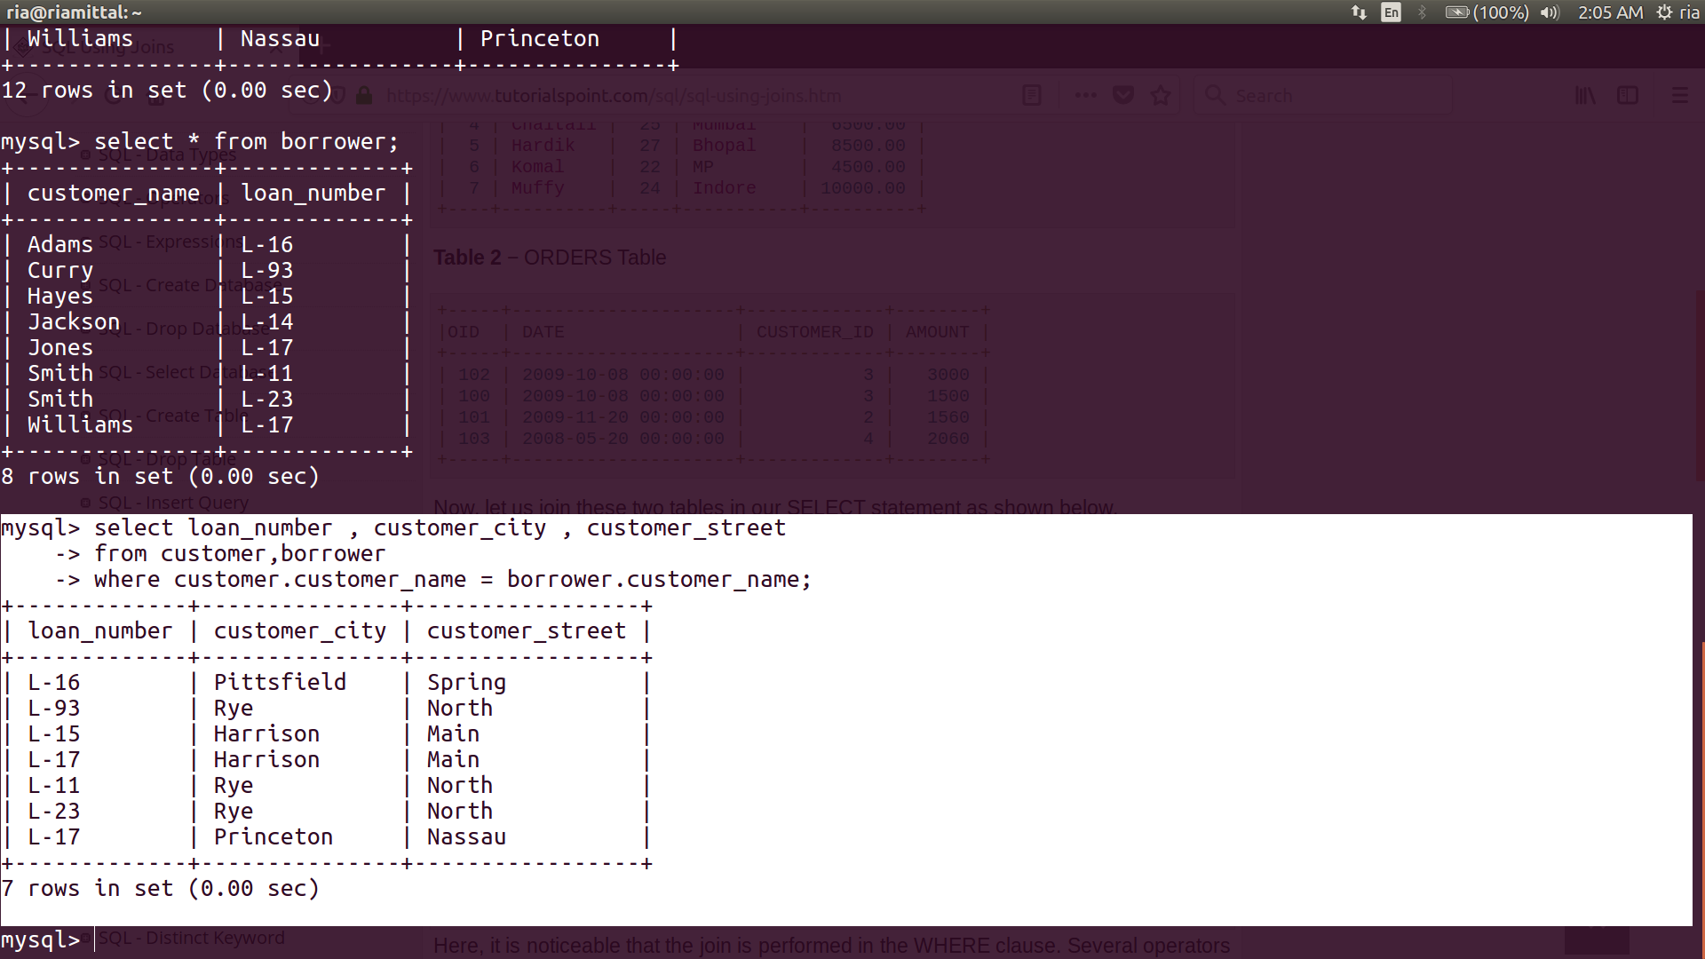

Example 2:

